L05: Preparation Assignment Answer Key
Name: ____________________

Part I: Use the information on the baseball batting averages given in the reading assignment to complete these questions. This information is found in Lesson 05 section “3.2.2 Baseball Averages” of the online textbook.

1. Classify each of the following batting averages as either “unusual” or “not unusual.”
a. 0.190 – Unusual (z=-2.088)

b. 0.225 – Not Unusual (z=-1.059)

c. 0.325 – Not Unusual (z=1.882)

d. 0.335 – Unusual (z=2.176)

- Find the probability that a randomly selected professional baseball player will have a batting average that is greater than 0.335.
The probability that a randomly selected professional baseball player will have a batting average that is greater than 0.335 is 0.015.
- Provide a brief description of a Normal Density Curve. Describe the shape and the properties.
The Normal Density curve is symmetric and has a bell shape. It is determined by its mean and standard deviation.
- In the following z-score formula, $z=\frac{(x-µ)}{σ}$ please state what each symbol stands for.
z = tells how many standard deviations away from the mean a certain observation lies. x = an observed data point. µ = mean of the population. $σ$ = standard deviation of the population.
- In no less than three sentences, please define and describe the 68-95-99.7% rule.

For any bell-shaped distribution, 68% of the data will lie within 1 standard deviation of the mean, 95% of the data will lie within 2 standard deviations of the mean, and 99.7% of the data will lie within 3 standard deviations of the mean.
This is called the 68-95-99.7% Rule for Bell-shaped Distributions. Needs to be at least three sentences.

Part II:

GRE Speed of
Scores Hydrogen
Mean 150.8 1800
Standard Deviation 8.8 600

- The mean of all quantitative scores on the GRE is 150.8 with a standard deviation of 8.8.

  - Scores on the quantitative portion of the GRE are approximately normally distributed with mean µ = __150.8______ and standard deviation σ = __8.8______.

  - What proportion of the people who take the quantitative portion of the GRE will score above 165?

Solution:
P(X > 165) = P(z > 1.6136) = 0.05330

c. If a student’s score is the 10th percentile, what would their corresponding z-score be?

Solution:
z = -1.2816; this is not unusual. See question 1.
d. What is the quantitative GRE score for a student who scores at the 10th percentile?

Solution:
GRE score = 139.5, which rounds to 140.
- The mean speed of hydrogen at room temperature is 1800 m/s with a standard deviation of 600 m/s.
  - At room temperature the mean speed of hydrogen (H₂) particles is approximately normal with a population mean of µ = __1800______ meters per second (m/s) and a standard deviation of
σ = __600______ m/s.

  - What is the probability that a randomly selected particle has a speed over 2500 m/s?
Solution:
P(X > 2500) = P(z > 1.1667) = 0.1217

c. What is the probability that a randomly selected particle has a speed that is less than 2500 m/s?

Solution:
P(X < 2500) = P(z < 1.1667) = 0.8783
This answer is easier to get by subtracting the answer to part (a) from 1.

d. What is the probability that a randomly selected particle has a speed that is less than 1500 m/s?

Answer:
P(X < 1500) = P(z < –0.5) = 0.3085

e. What is the probability that a randomly selected particle has a speed that is between 1500 and 2500 m/s?

Solution:
P( 1500 < X < 2500 ) = 0.5698

- What is the 3rd quartile of the speeds of hydrogen at room temperature?
Solution:
3rd quartile of the speeds of hydrogen = 2204.4 m/s

- Determine whether the data represented in these Q-Q plots are normally distributed or not. Record your answer for each graph. Justify your answer.
Plot A: Not Normal Plot B: Not Normal
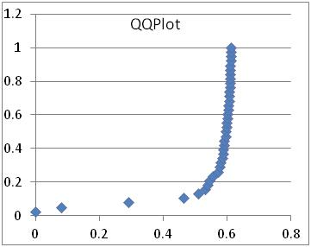 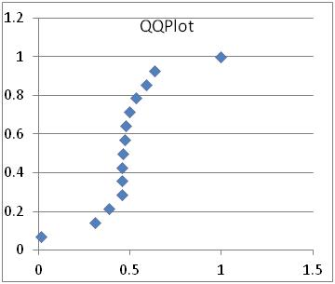
Plot C: Normal Plot D: Normal
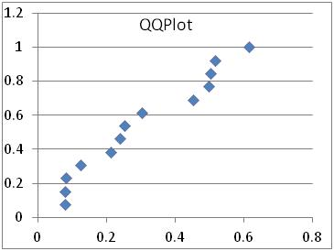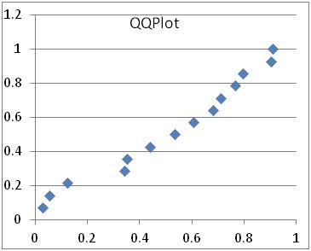
Plot E: Not Normal Plot F: Normal
